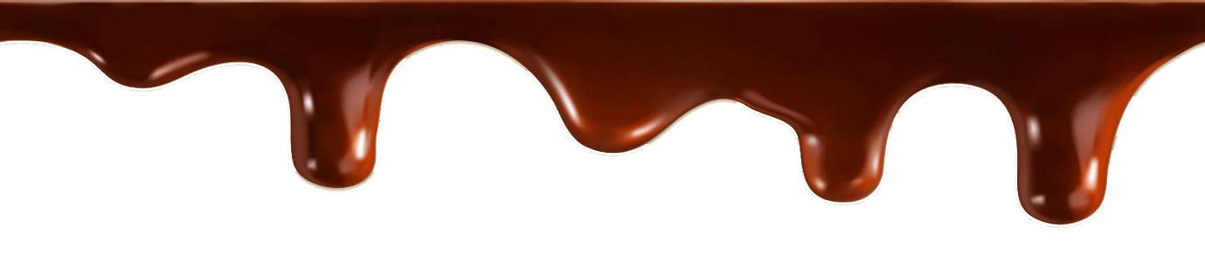

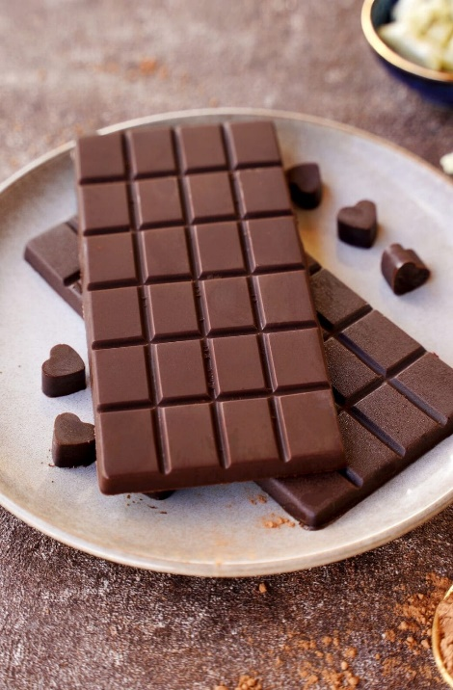

***Chemistry project***

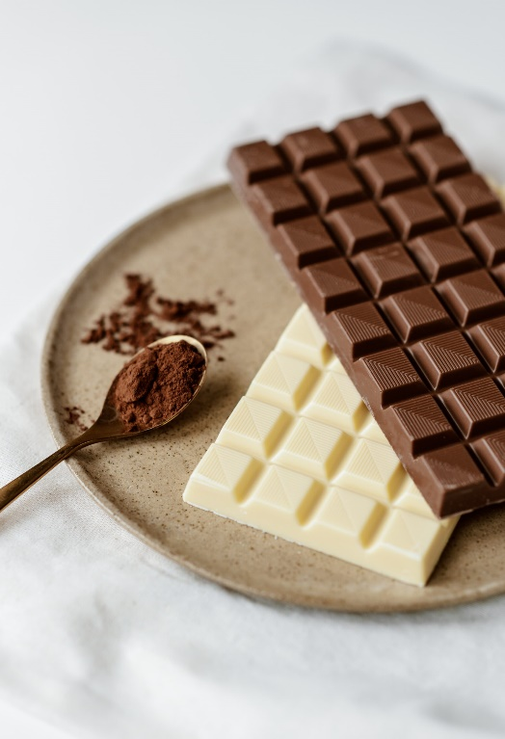

**BY:**

**SRI PRIYAN .P**

**PRANAV RAM .P.B**

**SRI VISHNU .M**

**POOJA .G**

**VENKATA BHAVIKA .T**





***index***

1.introduction

2.History of chocolate

3.melting test

4.compound and its iupac naming

5.test for fats and carbohydrates

6.materials required

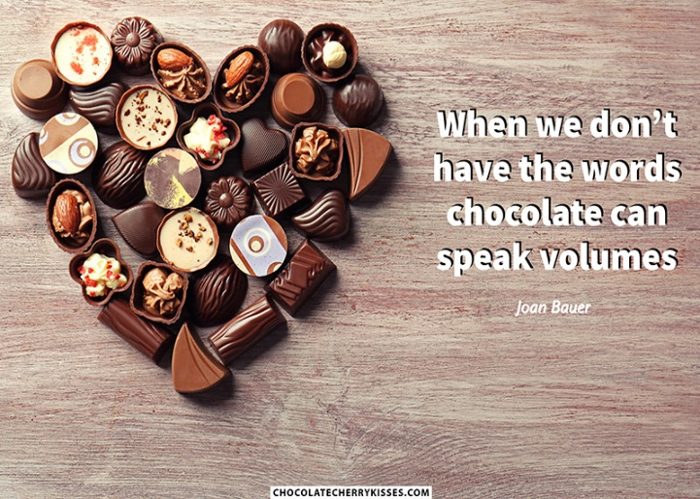7.procedure

8.observation

9.precautions

10.result

11.conclusion

**“Life is like a box of chocolates. You never know what you’re gonna get.”**



**Introduction:**

**Chocolate: A Sweet Indulgence**

Chocolate, a beloved treat enjoyed by people worldwide, is a confection made from roasted and ground cocoa beans. Its rich, creamy flavour and satisfying texture have captivated taste buds for centuries.

There are several types of chocolate, each with its own unique characteristics:

* **Dark chocolate:** Known for its intense flavour and high cocoa content, dark chocolate is often considered the most healthful type due to its antioxidant properties.
* **Milk chocolate:** A popular choice among children and adults, milk chocolate combines the sweetness of milk with the bitterness of cocoa.
* **White chocolate:** Made primarily from cocoa butter, sugar, and milk, white chocolate is lighter in flavour and has a creamy texture.
* **Bittersweet chocolate:** A blend of dark and milk chocolate, bittersweet chocolate offers a balance of sweetness and bitterness.

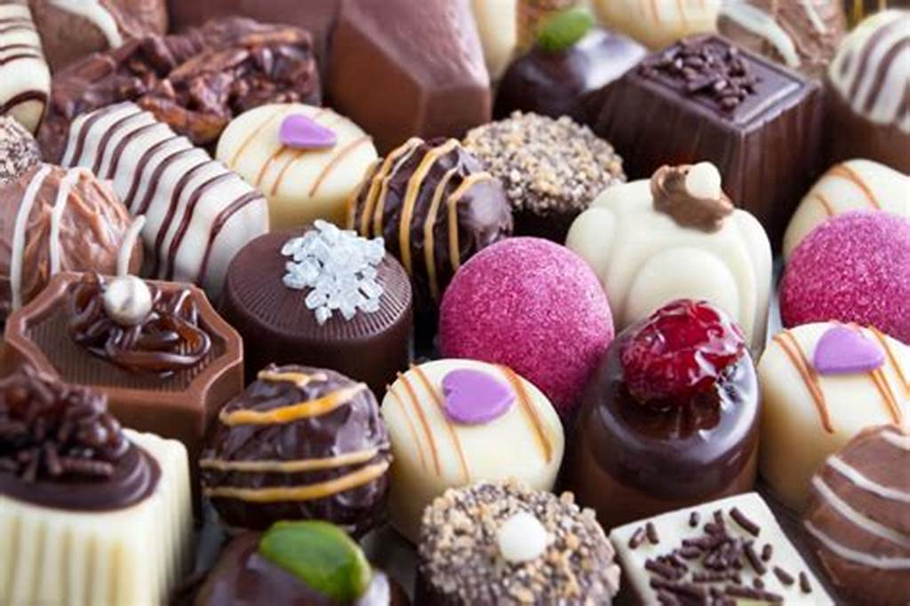Chocolate is often enjoyed as a snack, dessert, or ingredient in various culinary creations. It can be found in everything from cakes and cookies to ice cream and candy bars.



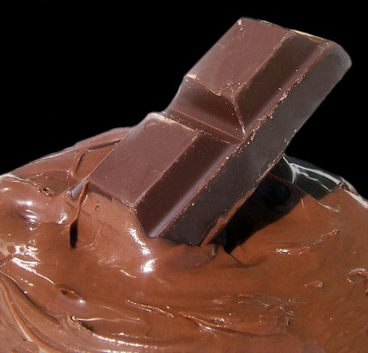 **Chocolates and its uses:**

Chocolate is a versatile ingredient that can be used in countless ways. Beyond its delicious taste, chocolate has also been linked to certain health benefits. Studies have suggested that consuming dark chocolate in moderation may help lower blood pressure, improve heart health, and enhance cognitive function.

Chocolate is a versatile ingredient that can be used in countless ways. Here are some common uses:

* **Confectionery:** Chocolate is a primary ingredient in various candies, such as bars, truffles, and bonbons.
* **Baking:** Chocolate is often used in cakes, cookies, brownies, and other baked goods, adding flavour and richness.
* **Ice Cream:** Chocolate is a popular flavour for ice cream, often combined with other ingredients like nuts or caramel.
* **Beverages:** Hot chocolate, chocolate milk, and chocolate-flavoured coffee are popular beverages.
* 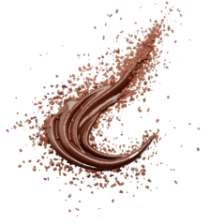**Cooking:** Chocolate can be used as a flavouring agent in sauces, puddings, and mousses.
* **Health and Beauty:** Some chocolate-based products are used for skin care and hair care.



**The History of Chocolate:**

**Origins in Mesoamerica**

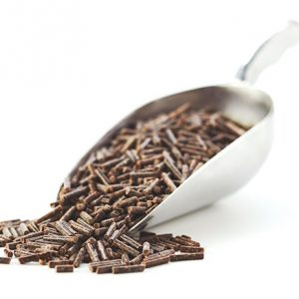 The story of chocolate begins in Mesoamerica, particularly in the region now known as Mexico and Central America.

Ancient civilizations like the Olmec, Maya, and Aztec prized cocoa beans, the raw material for chocolate. They believed cocoa beans were a gift from the gods and used them in religious ceremonies and as a currency.

* **The Olmec:** One of the earliest known civilizations to use cocoa beans, the Olmec are believed to have developed the first chocolate drink around 1,900 BCE.
* **The Maya:** The Maya refined the chocolate drink, adding spices like vanilla, chili peppers, and cornmeal. They also associated chocolate with the god of fertility and abundance.
* 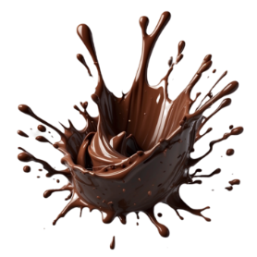**The Aztec:** The Aztec highly valued chocolate, using it as a tribute to their gods and as a reward for warriors. They prepared a frothy chocolate drink called *xocalatl*.

***"When you feel like dying, chocolate tastes even better than usual."***

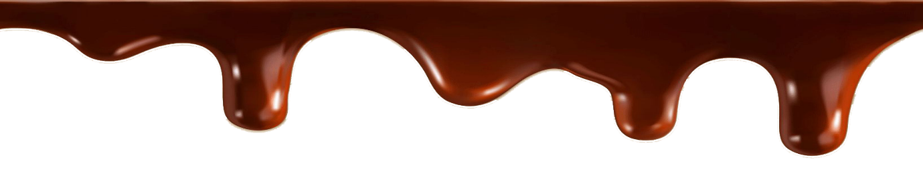

**compound and its iupac naming:**

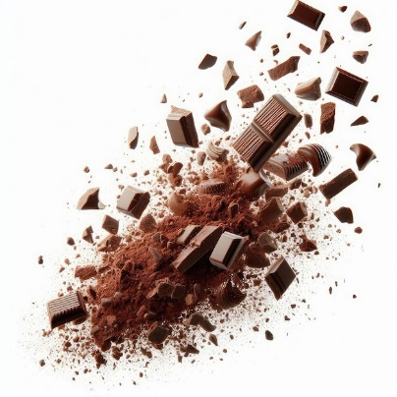**iupac:**

* 3,7-dimethylxanthine

**common name:**

* Theobromine

**structure:**

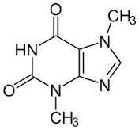

Theobromine is the principle alkaloid in the cacao bean. It has 1 hydrogen bond donor site and 3 hydrogen bond acceptor sites. There is no formal charge, 4 pi bonds which contribute to resonance, and 2 methyl groups.

**Melting test:**

|  |  |
| --- | --- |
| brand | time |
| Dairy milk |  |
| galaxy |  |
| silk |  |
| Milky bar |  |
| Amul-dark chocolate |  |



**Testing for Fats and Carbohydrates in Different Types of CHOCOLATES Using Fehling's Reagent**

**aim:**

To test for the presence of carbohydrates (specifically reducing sugars) in different types of chocolate using Fehling's Reagent A and B, and to test for fats using a separate fat test.

**theory:**

* 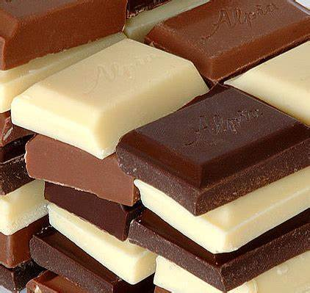Fehling's Test for Reducing Sugars (Carbohydrates): Carbohydrates like glucose and maltose are reducing sugars, which can reduce Fehling's solution. Fehling's reagent is a combination of two solutions:
* Fehling's A: Contains copper(II) sulphate.
* Fehling's A: Contains copper(II) sulphate.
* Fehling's B: Contains potassium sodium tartrate and sodium hydroxide.

When reducing sugars are heated with Fehling's solution, the copper(II) ions (blue) are reduced to copper(l) ions, which form a red precipitate of copper(I) oxide, indicating the presence of reducing sugars.

* Fat Test: Fats are detected by the grease spot test, where lipids leave a translucent stain on filter paper when pressed against it.



**materials required:**

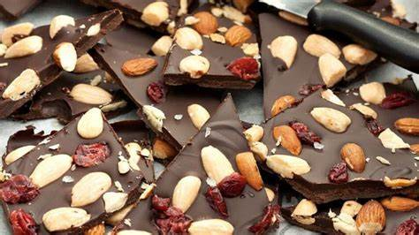**For Carbohydrate Test:**

* Fehling's Reagent A
* Fehling's Reagent B
* Fehling's Reagent B
* Test tubes
* Test tube holder
* Water bath or Bunsen burner
* Distilled water
* Dropper
* Different types of chocolates (e.g ., galaxy, dairy milk, milky bar, amul-dark chocolate , silk)
* 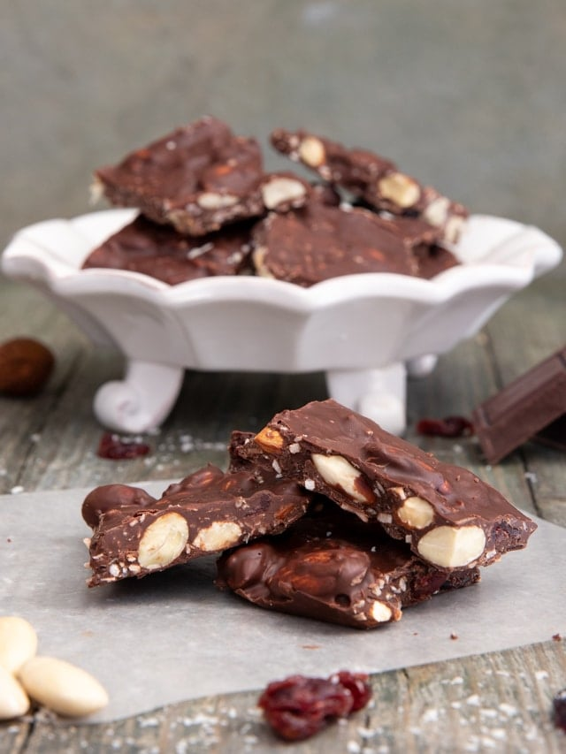Measuring spoon or spatula
* Lab coat

**For Fat Test:**

* Filter paper
* Different types of
* Mortar and pestle
* Mortar and pestle
* Distilled water (optional for making paste)
* Spatula or dropper



**Procedure:**

**Part 1:** **Test for Carbohydrates (Reducing Sugars) using Fehling's Reagent**

**1. Preparation of food samples:**

* Smash the chocolates (galaxy, dairy milk, milky bar , amul-dark chocolate , silk)
* 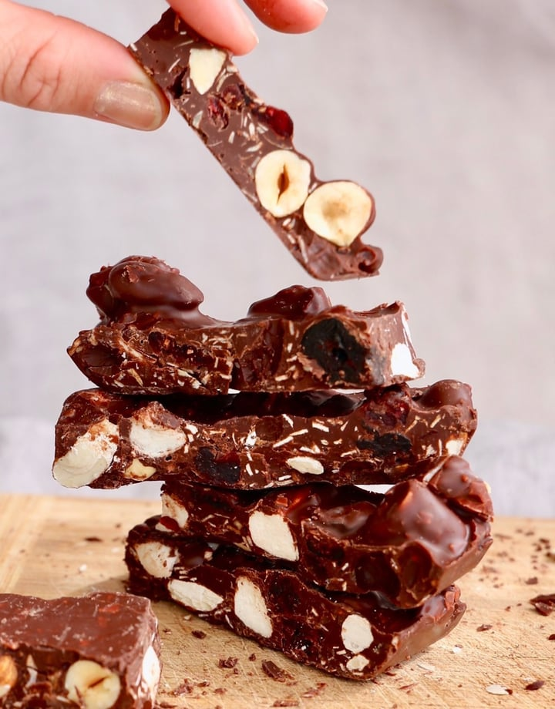Mix the smashed chocolate with a little distilled water to make a solution.

**2. Testing with Fehling's Solution:**

* Take 3 clean test tubes and label them for each type of chocolate.
* Add 2 ml of the chocolate solution into each test tube.
* Add 1 ml of Fehling's A solution and 1 ml of Fehling's B solution to each test tube.
* Heat the test tubes in a water bath or over a Bunsen burner for about 5-10 minutes.
* Observe the colour change.

**Par t 2: Test for Fats using Grease Spot Test**

**1. Testing for Fats:**

* Take a small piece of each chocolate and press it against a clean, dry piece of filter paper.
* Wait for a few minutes for any fat
* Wait for a few minutes for any fat to seep into the paper.



* 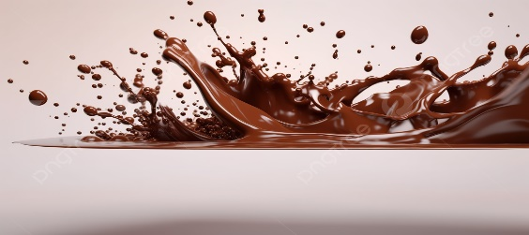Hold the paper up to light and observe for any translucent (greasy) spots.

**Observations:**

|  |  |  |
| --- | --- | --- |
| **Chocolate type** | **Fehling's Test**  **Observation** | **Fat Test Observation** |
| Cream Biscuit | Brick-red precipitate | Translucent spot (fat  present) |
| Digestive Biscuit | Green/yellow precipitate | Translucent spot (fat  present) |
| Glucose Biscuit | Brick-red precipitate | Slight Translucent spot (fat  present) |

* 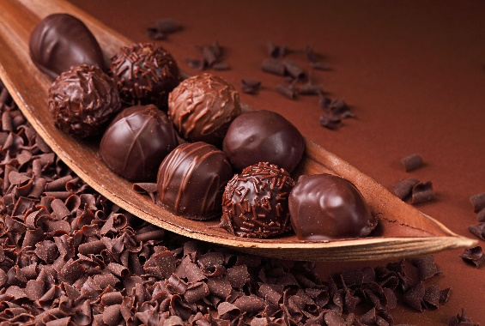 Carbohydrate Test (Fehling's): The presence of reducing sugars will result in a brick-red precipitate. If no precipitate is formed, the chocolate contains no or very little reducing sugar.
* Fat Test: A translucent spot on the filter paper indicates the presence of fat. A more pronounced translucent spot suggests a higher fat content.

**Precautions:**

* Handle Fehling's reagent carefully, asit can be harmful if it comes intocontact with skin or eyes.
* Heat the test tubes gently to avoid splashing. Clean test tubes before use to avoid contamination.



* Wear a lab coat during the experiment
* Make sure the are properly ground to create an effective solution for testing.

**results:**

* 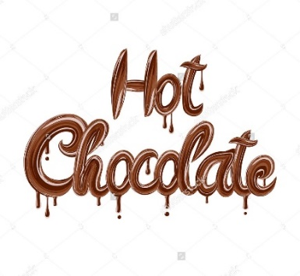Cream Biscuit: Showed a positive result for both reducing sugars (brick-red precipitate) and fats (translucent spot).
* Digestive Biscuit: Contained moderate reducing sugars (yellow or green precipitate) and fats (translucent spot).
* Glucose Biscuit: Contained high amounts of reducing sugars (brick-red precipitate) but lower fat content (slight translucent spot).

**conclusion:**

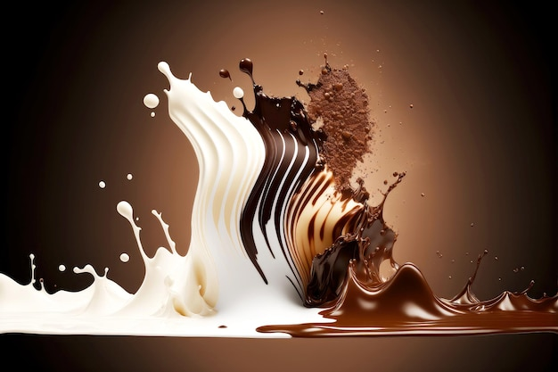 All tested positive for reducing sugars, with glucose and cream showing higher sugar content. Fat was present in all with cream showing the highest fat content. This experiment effectively identified the presence of both carbohydrates and fats in the different chocolate samples.

~~~THE END~~~